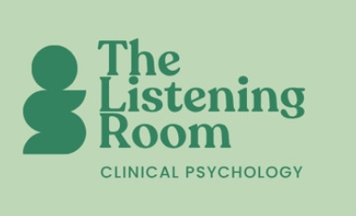
Online Therapy with Dr Emma Agnew

www.thelisteningroompsychology.com
email: dremmaagnew@outlook.com

Management of Personal Information: Privacy Policy
This document outlines the privacy policy of The Listening Room Psychology regarding the collection, use, and management of clients’ personal information. This service complies with the Australian Privacy Principles under the Privacy Act 1988 (Cth).
Client information
Client records are securely stored in an encrypted, cloud-based system within an online booking platform that meets medical-grade security standards. Access is restricted solely to Emma Agnew.
Information collected may include personal details such as name, address, contact information, medical history, and other relevant information necessary for providing psychological services. Personal information may also be stored within a secure, internet-based appointment scheduling system.
How clients' personal information is collected
Personal information is collected in several ways during the course of providing psychological services, including:
- Information provided directly by clients (e.g., intake forms, correspondence, and consultations)
- Communication via email
- Information received from other health professionals (e.g., referrals, reports, or correspondence)

Consequence of not providing personal information
If a client chooses not to provide personal information as outlined in this policy, it may not be possible to offer psychological services.
Purpose of holding personal information
Personal information is collected and used to deliver psychological services, including assessment, diagnosis, and treatment. It is also used to maintain accurate records of sessions, enabling the provision of safe, appropriate, and effective care.

Disclosure of personal information
All personal information is treated as confidential and will only be disclosed under the following circumstances:
- Where required or authorised by law (e.g., subpoena)
- Where there is a reasonable belief that non-disclosure would pose a serious risk to the client or others
- With the client’s consent (or that of a legally authorised guardian), including:
  - Providing reports to other professionals (e.g., GP, lawyer)
  - Discussing information with relevant third parties (e.g., parent, employer, insurer)
  - Clinical consultation with other professionals (without identifying details)
  - Disclosure for purposes directly related to the original reason for collection

Personal information will not be shared with overseas recipients without consent or unless required by law. It will not be used, sold, rented, or disclosed for any unrelated purpose.
In the event of a data breach, all reasonable steps will be taken to minimise the risk of harm, including activation of a data breach response plan.
Requests for access and correction to client information
Clients may request access to, or correction of, their personal information at any time. Requests should be made to Emma Agnew and will be responded to in writing within 21 days. An appointment may be arranged if clarification is required.
If information is found to be inaccurate, outdated, or incomplete, reasonable steps will be taken to correct it.
Concerns
If you have concerns about how your personal information is managed, you are encouraged to raise them with Emma Agnew. You may also access the Australian Privacy Principles for further information about your rights.
If you wish to make a formal complaint, you can contact the Office of the Australian Information Commissioner:
- Phone: 1300 363 992
- Online: http://www.oaic.gov.au/privacy/making-a-privacy-complaint
- Post: GPO Box 5218, Sydney NSW 2001

